Ex-no: 8 M. Rohith
07-05-2024 3122 21 5001 085

Exercise-8 (Dynamic Dropdown Menu)

Develop a dynamic Dropdown Menu web application using AJAX with Servlets. Use the given sample code and modify the display content as dropdown menu instead of table and apply an event to dropdown, as it displays the selected item value in paragraph tag:

WebApp Structure:
ApacheTomcat→webapps
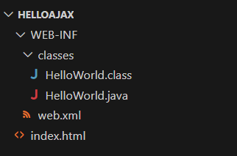

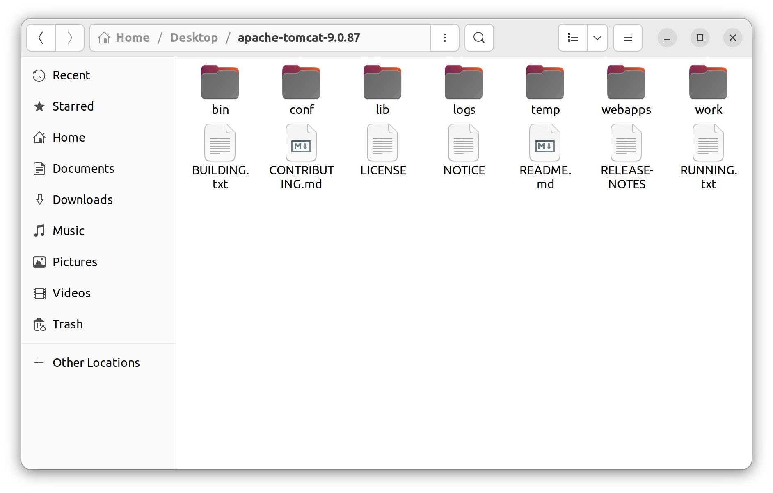

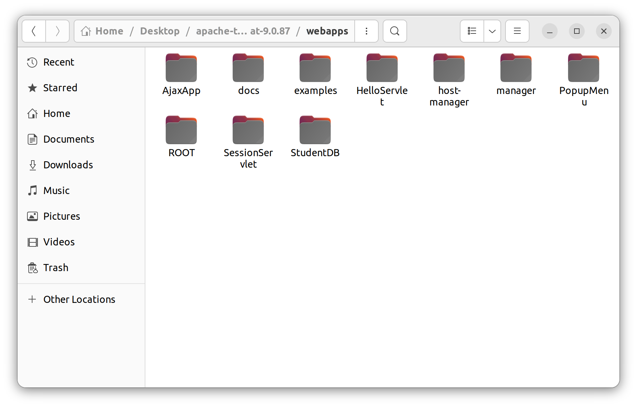

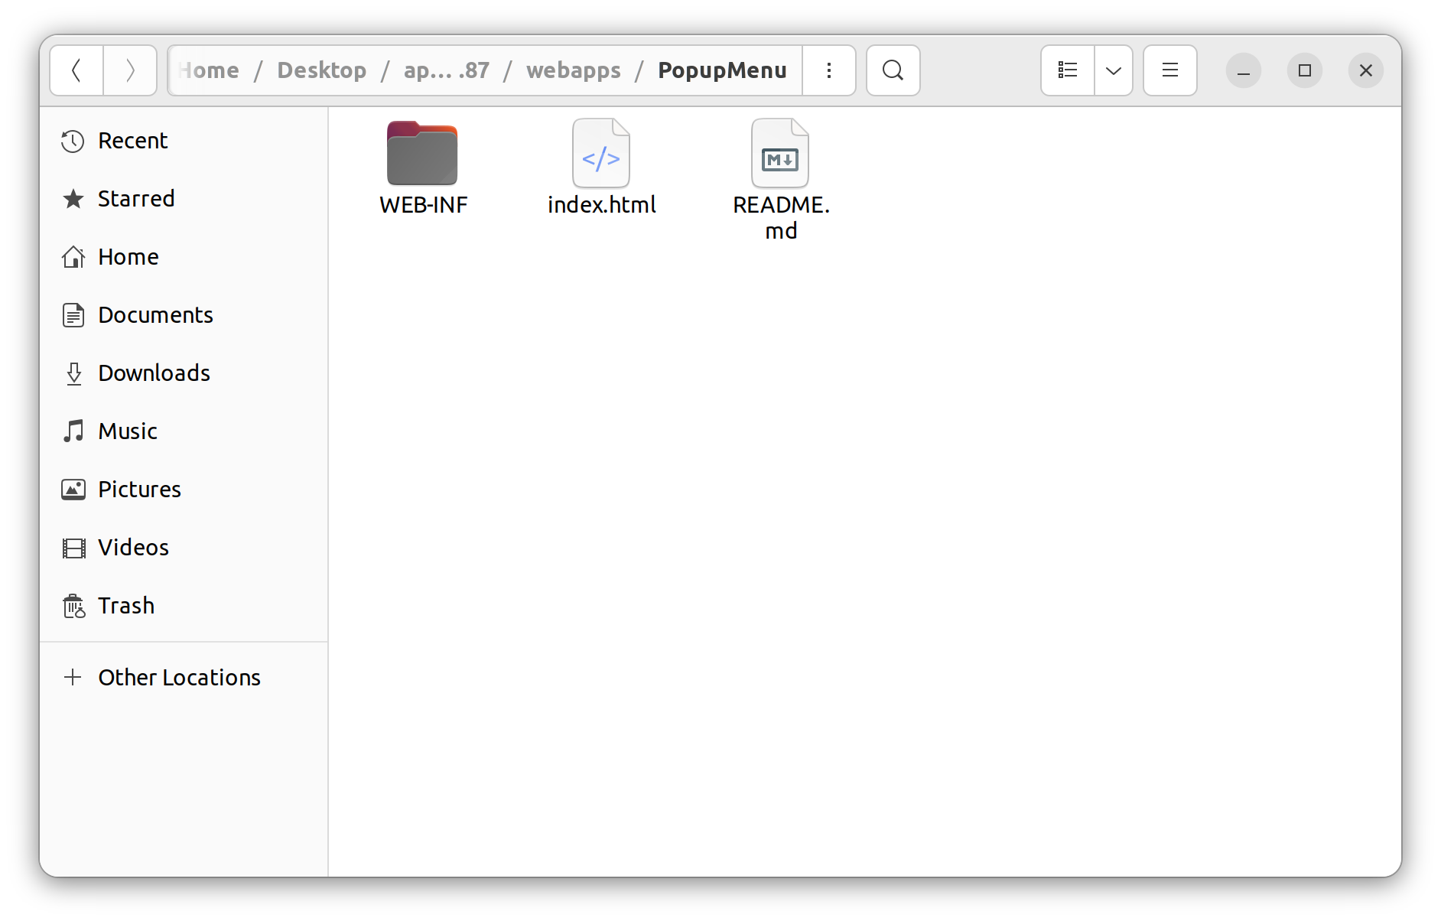

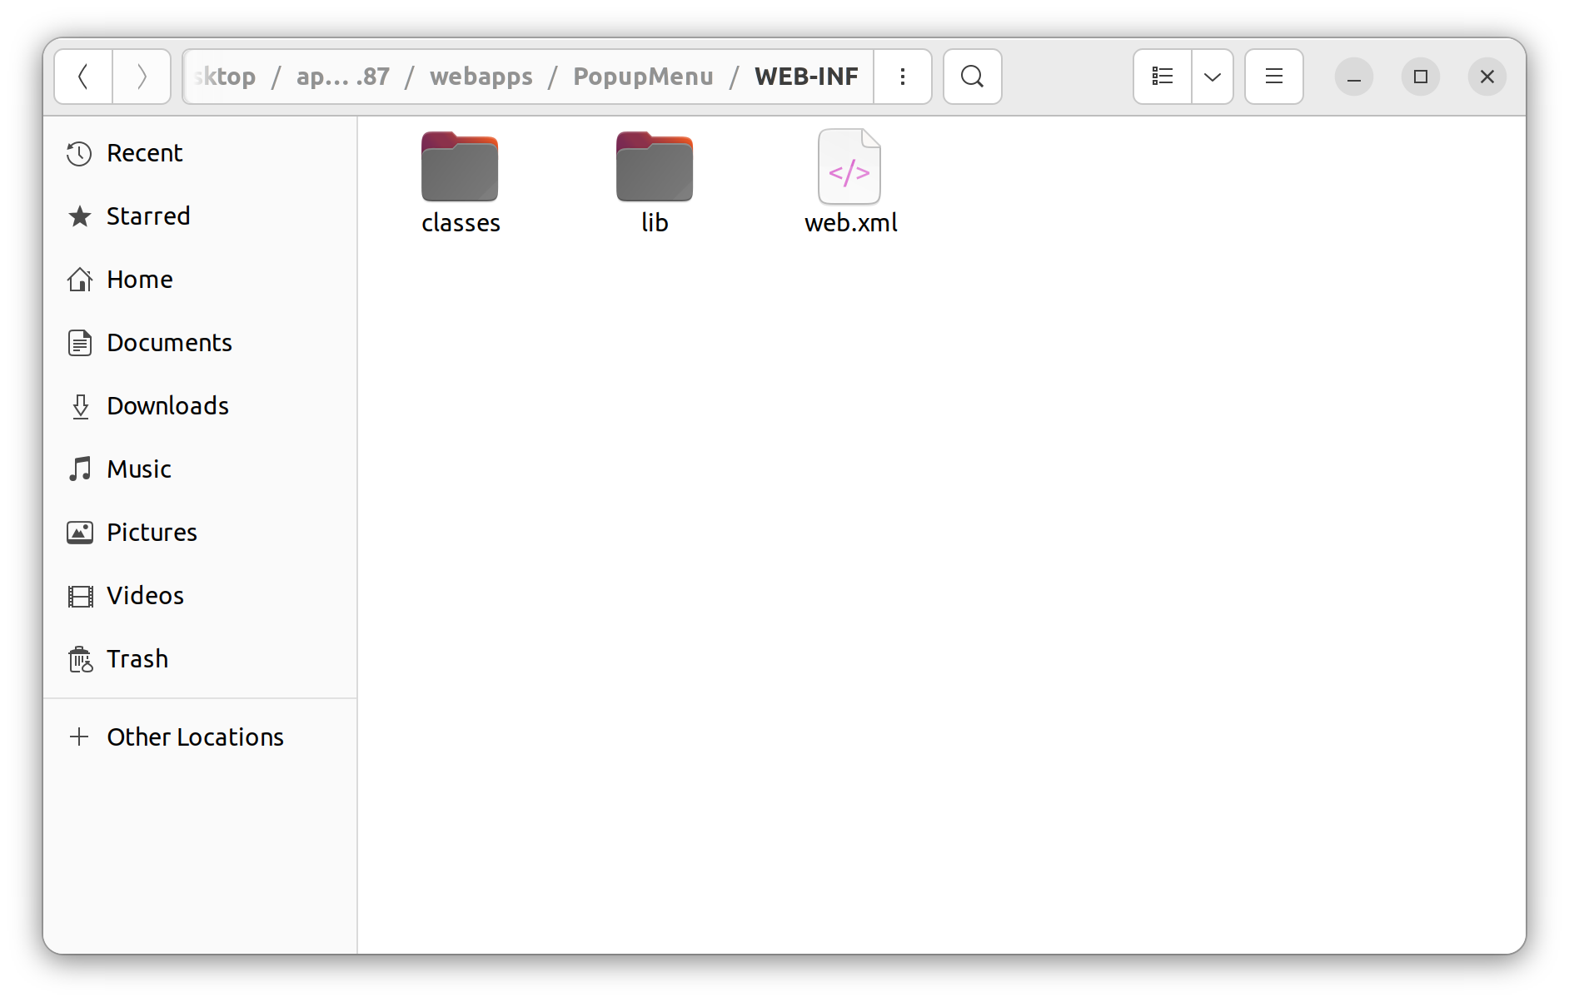

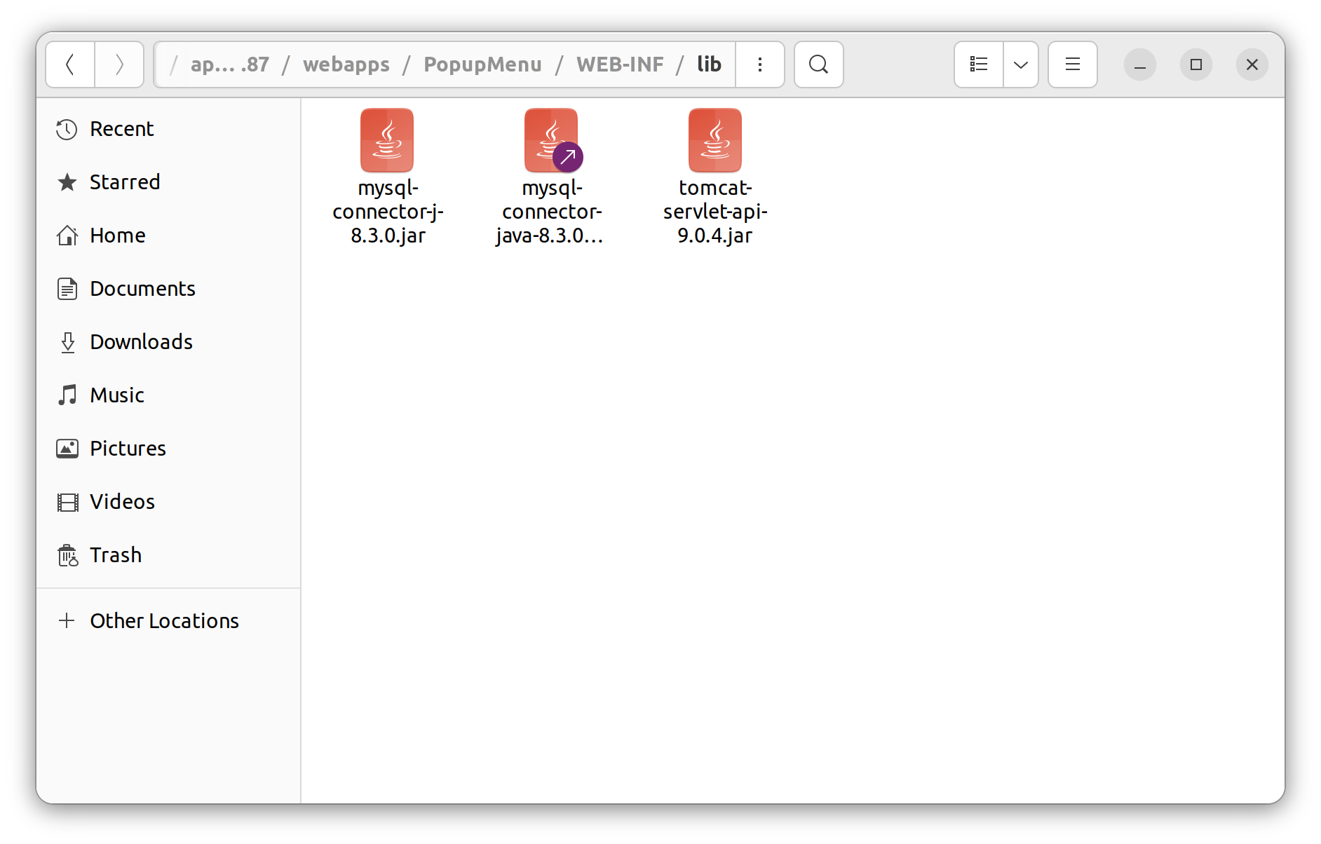

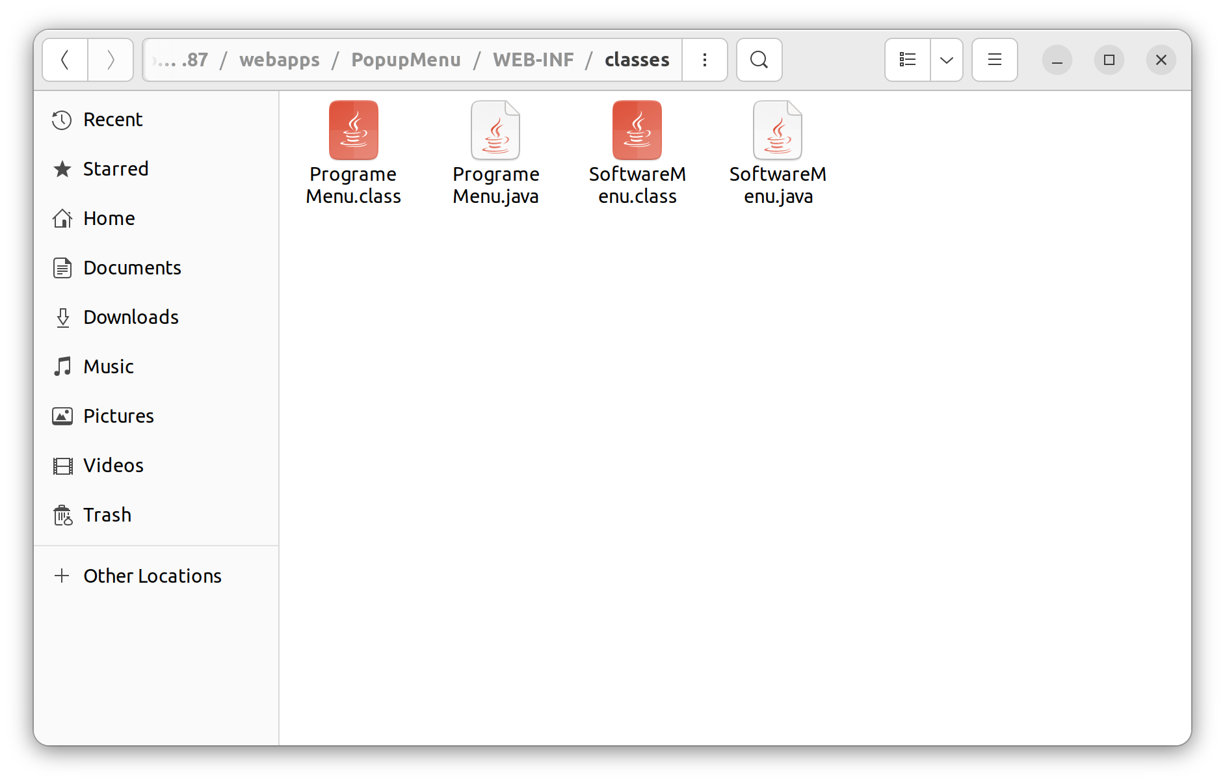

Program code:

ProgrameMenu.java

import java.io.*;
import javax.servlet.*;
import javax.servlet.http.*;
import java.sql.*;

public class ProgrameMenu extends HttpServlet {

static {
try {
Class.forName("com.mysql.cj.jdbc.Driver");
} catch (ClassNotFoundException e) {
throw new RuntimeException("Error loading MySQL JDBC driver", e);
}
}

public void doGet(HttpServletRequest request, HttpServletResponse response) throws IOException, ServletException {
response.setContentType("text/html");
PrintWriter out = response.getWriter();

try (
Connection conn = DriverManager.getConnection("jdbc:mysql://localhost:3306/popupmenu", "user",
"password");
Statement stmt = conn.createStatement();) {
String sql = "SELECT toolname FROM development WHERE type='programming'";
ResultSet result = stmt.executeQuery(sql);
int rowCount = 0;

while (result.next()) {
String toolName = result.getString("toolname");
out.println("<p>" + toolName + " </p>");
}
} catch (Exception e) {
// TODO: handle exception
}

out.close();
}
}

SoftwareMenu.java

import java.io.*;
import javax.servlet.*;
import javax.servlet.http.*;
import java.sql.*;

public class SoftwareMenu extends HttpServlet {

static {
try {
Class.forName("com.mysql.cj.jdbc.Driver");
} catch (ClassNotFoundException e) {
throw new RuntimeException("Error loading MySQL JDBC driver", e);
}
}

public void doGet(HttpServletRequest request, HttpServletResponse response) throws IOException, ServletException {
response.setContentType("text/html");
PrintWriter out = response.getWriter();

try (
Connection conn = DriverManager.getConnection("jdbc:mysql://localhost:3306/popupmenu", "user",
"password");
Statement stmt = conn.createStatement();) {
String sql = "SELECT toolname FROM development WHERE type='software'";
ResultSet result = stmt.executeQuery(sql);
int rowCount = 0;

while (result.next()) {
String toolName = result.getString("toolname");
out.println("<p>" + toolName + " </p>");
}
} catch (Exception e) {
// TODO: handle exception
}

out.close();
}
}

web.xml

<web-app>

<servlet>
<servlet-name>ProgrameMenu</servlet-name>
<servlet-class>ProgrameMenu</servlet-class>
</servlet>
<servlet-mapping>
<servlet-name>ProgrameMenu</servlet-name>
<url-pattern>/programeMenu</url-pattern>
</servlet-mapping>

<servlet>
<servlet-name>SoftwareMenu</servlet-name>
<servlet-class>SoftwareMenu</servlet-class>
</servlet>
<servlet-mapping>
<servlet-name>SoftwareMenu</servlet-name>
<url-pattern>/softwareMenu</url-pattern>
</servlet-mapping>

<welcome-file-list>
<welcome-file>index.html</welcome-file>
</welcome-file-list>
</web-app>

index.html

<!DOCTYPE html>
<html lang="en">

<head>
<meta charset="UTF-8">
<meta name="viewport" content="width=device-width, initial-scale=1.0">
<title>Popup Menu App</title>
<script>
function showMenu(position) {
var xhttp = new XMLHttpRequest();

xhttp.onreadystatechange = function () {
if (this.readyState == 4 && this.status == 200) {
document.getElementById(position).innerHTML = this.responseText;
}
};
xhttp.open("GET", "/PopupMenu/" + position, true);

xhttp.send();
}

function resetMenu(position){
document.getElementById(position).innerHTML = "";
}
</script>
</head>

<body>
<h1>Popup Menu</h1>
<section style="display: flex;">
<h1 onclick="showMenu('programeMenu')" onmouseout="resetMenu('programeMenu')">Programming <div id="programeMenu" style="font-size: medium;">.</div>
</h1>
<div style="width: 100px;"></div>
<h1 onclick="showMenu('softwareMenu')" onmouseout="resetMenu('softwareMenu')">Software <div id="softwareMenu" style="font-size: medium;">.</div>
</h1>
</section>
</body>

</html>

Output:

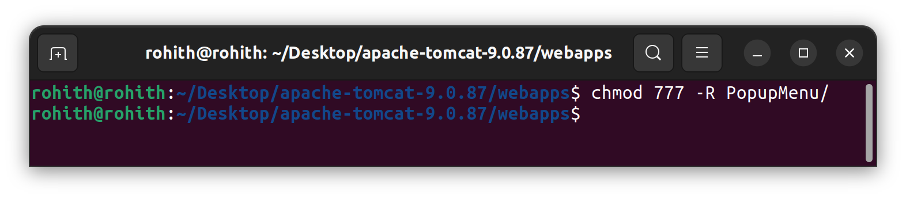

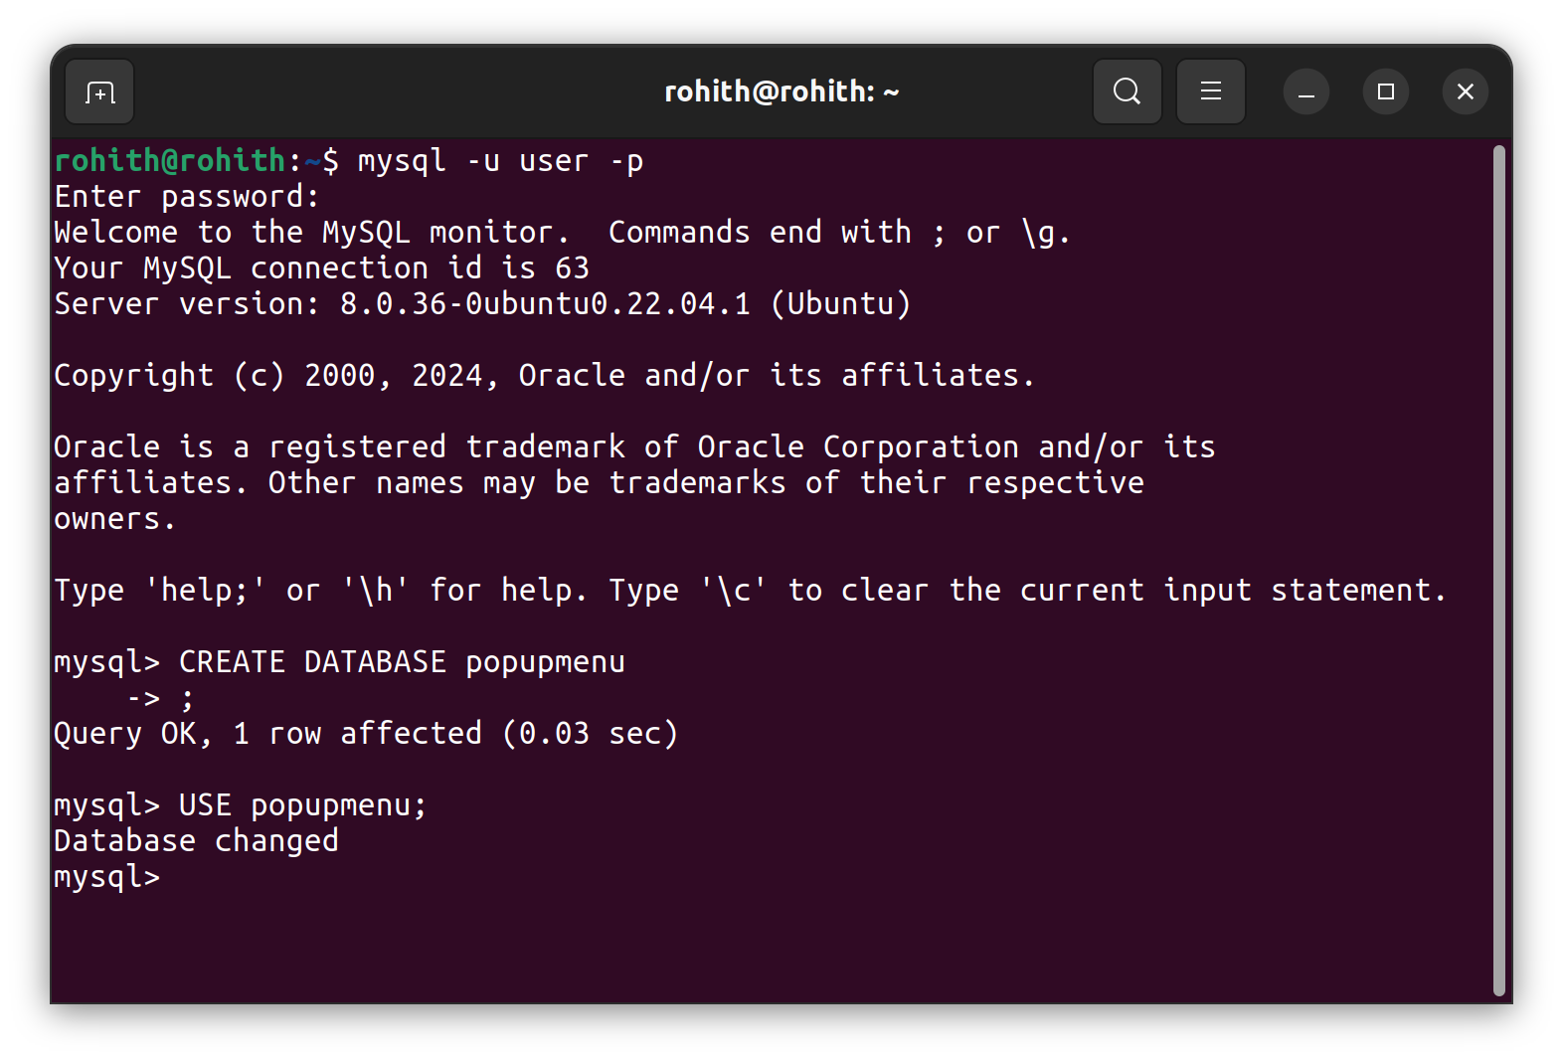

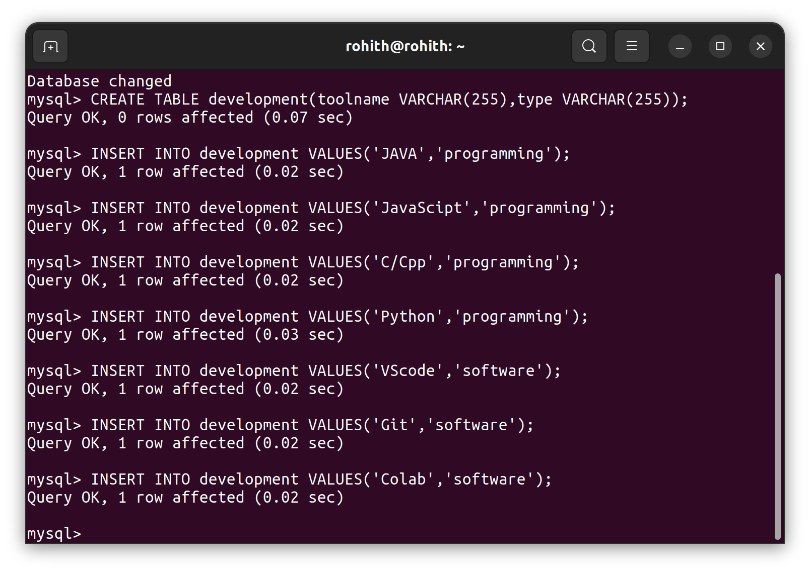

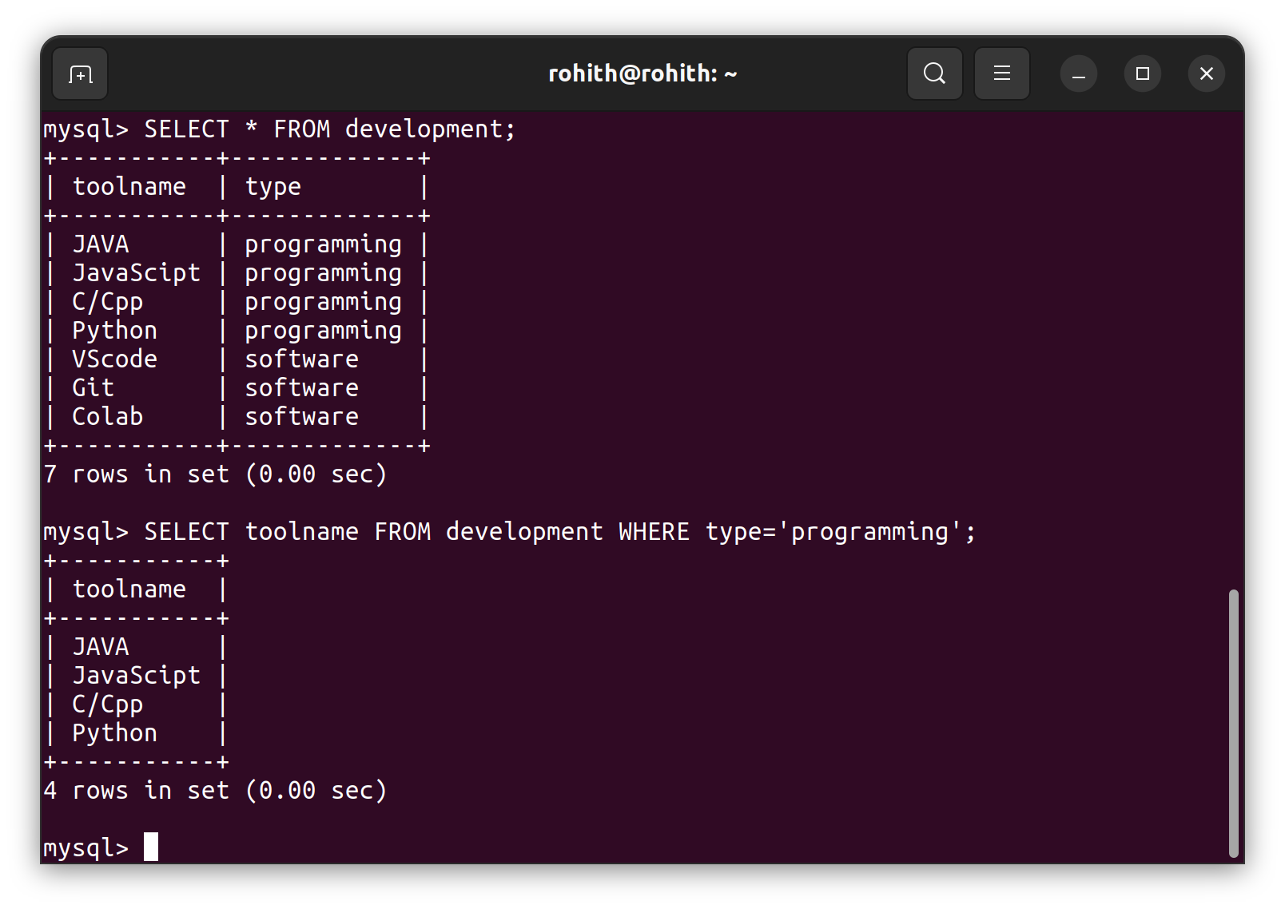
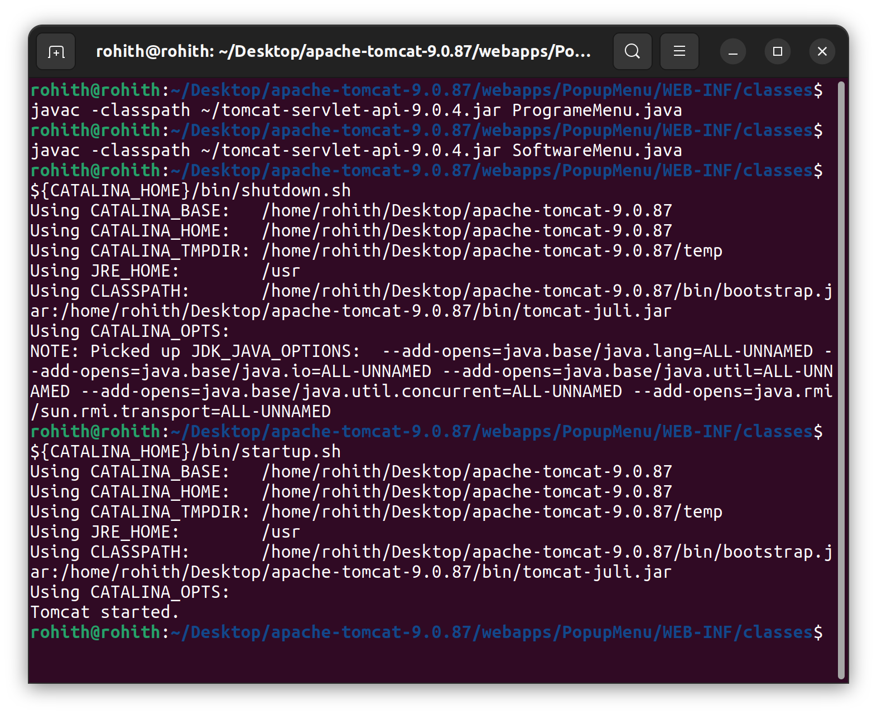

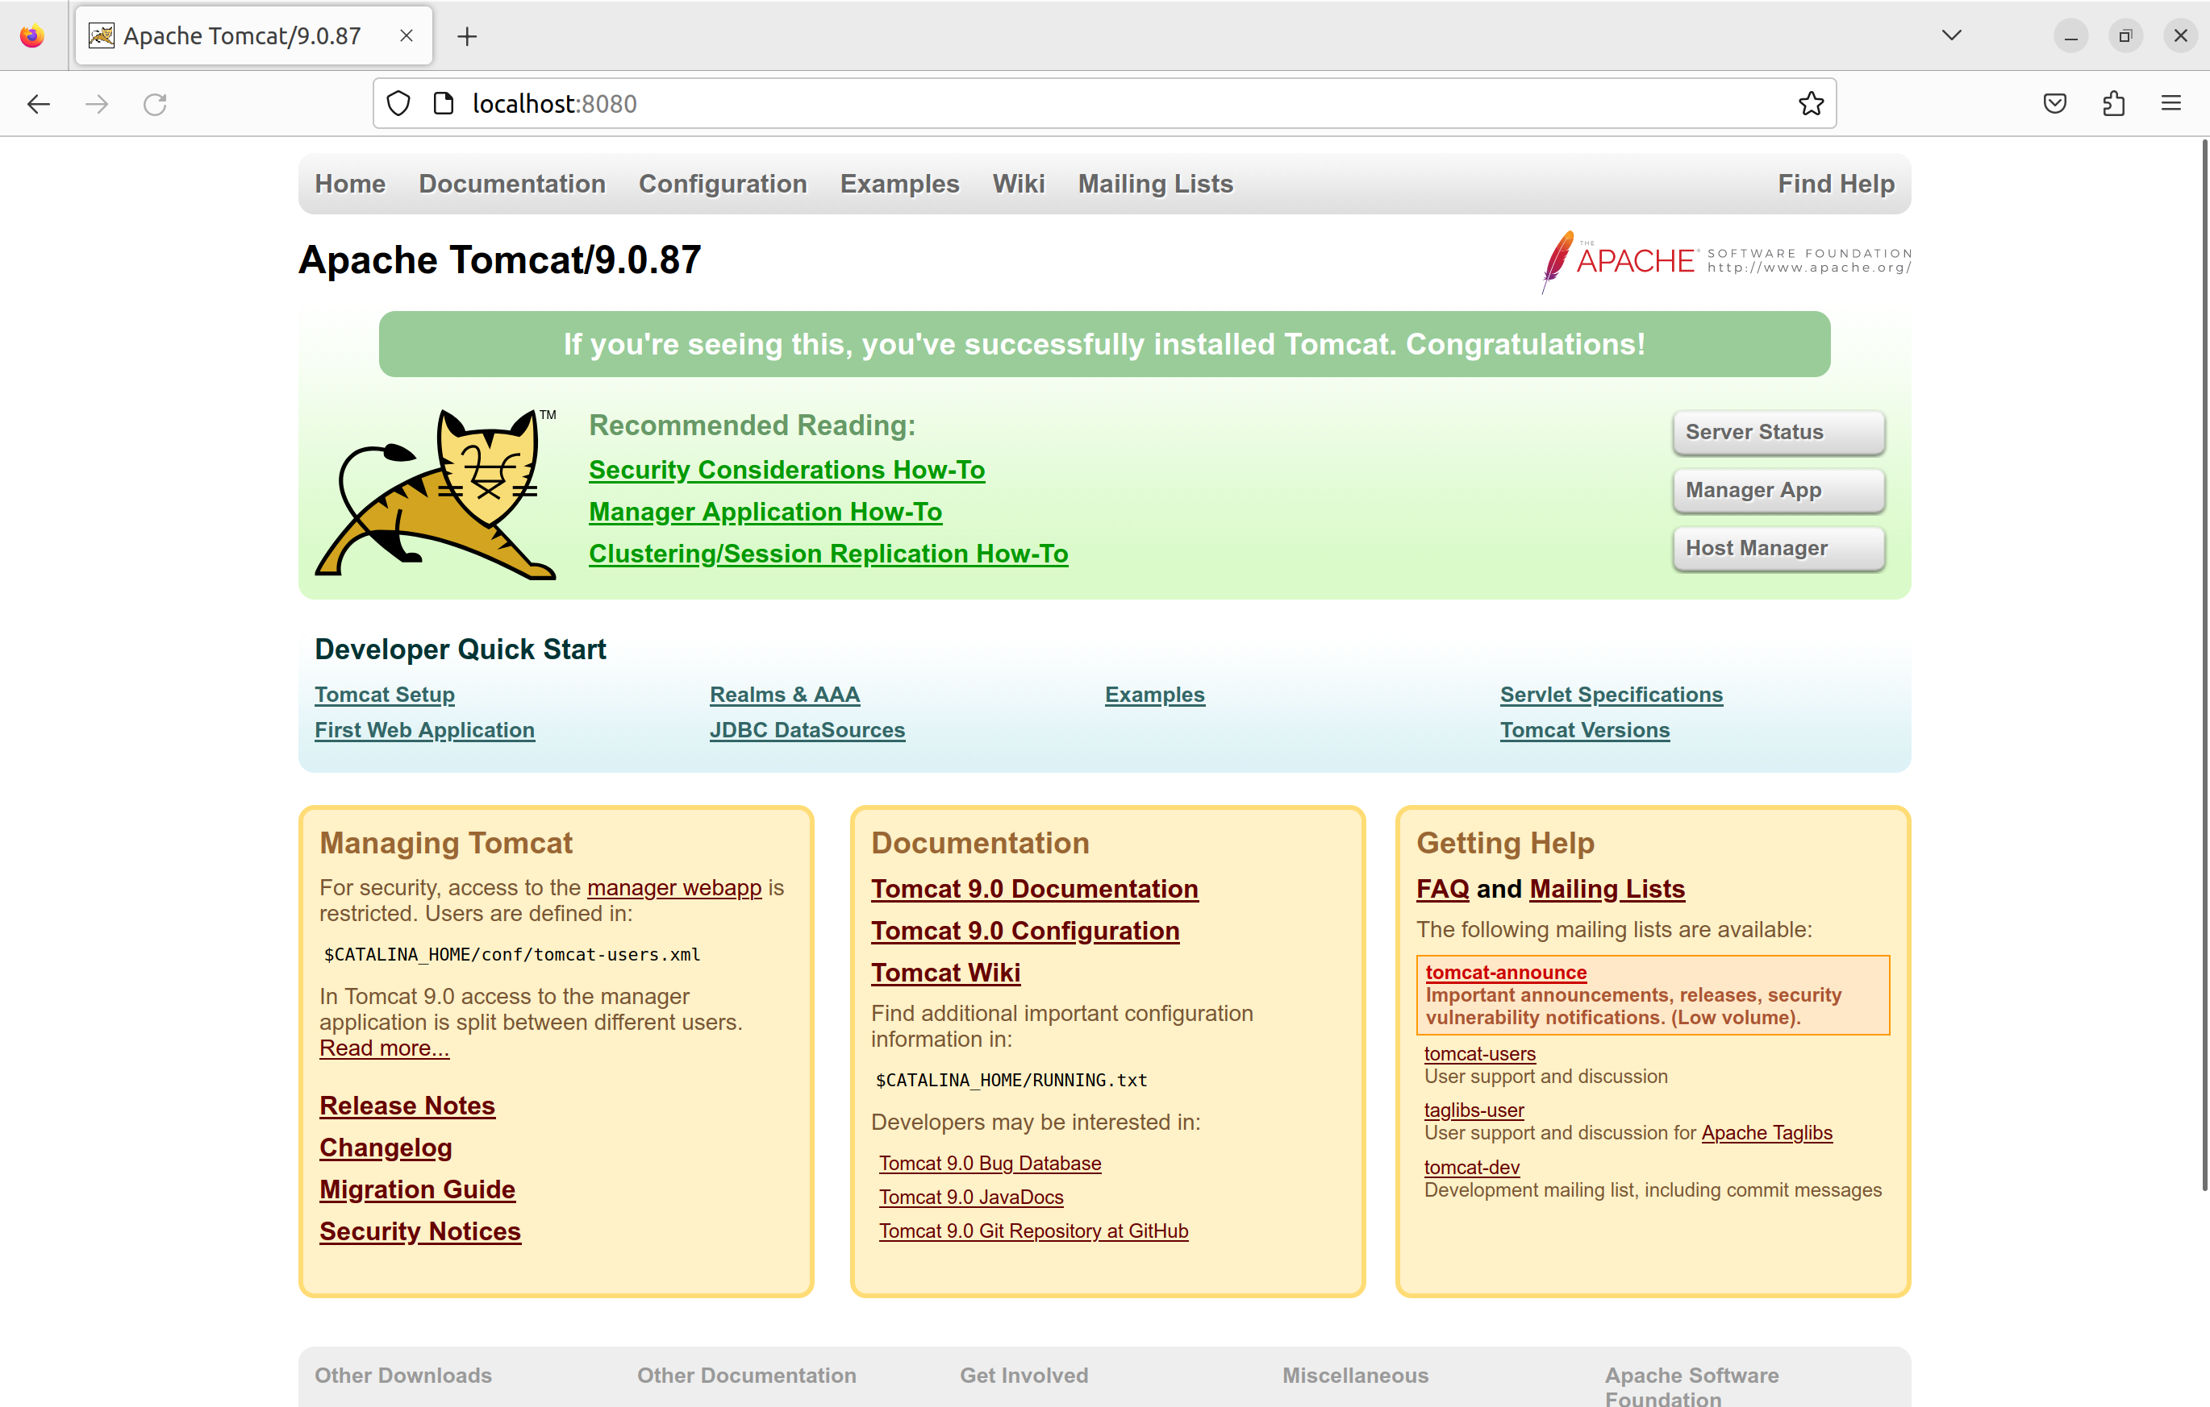

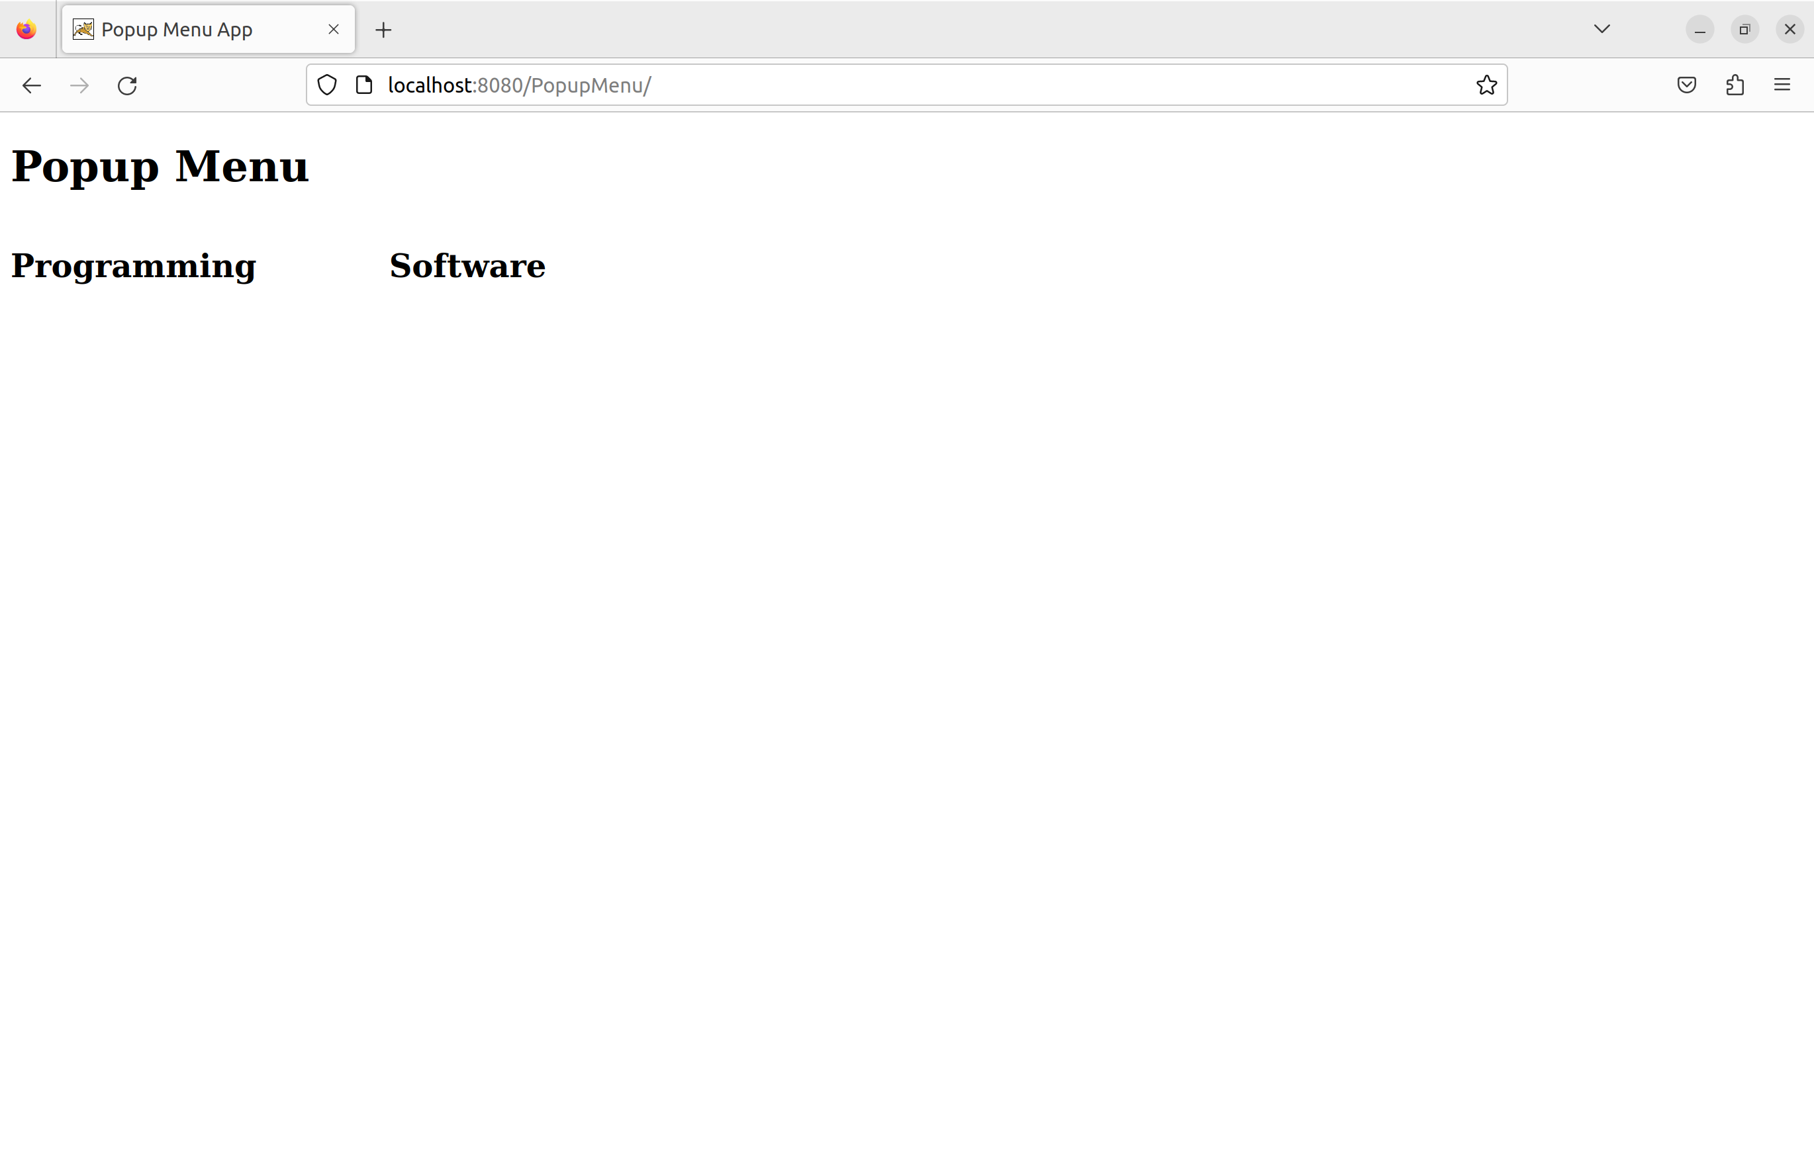

Move the mouse over “Programming” or click on it to display Programming content.

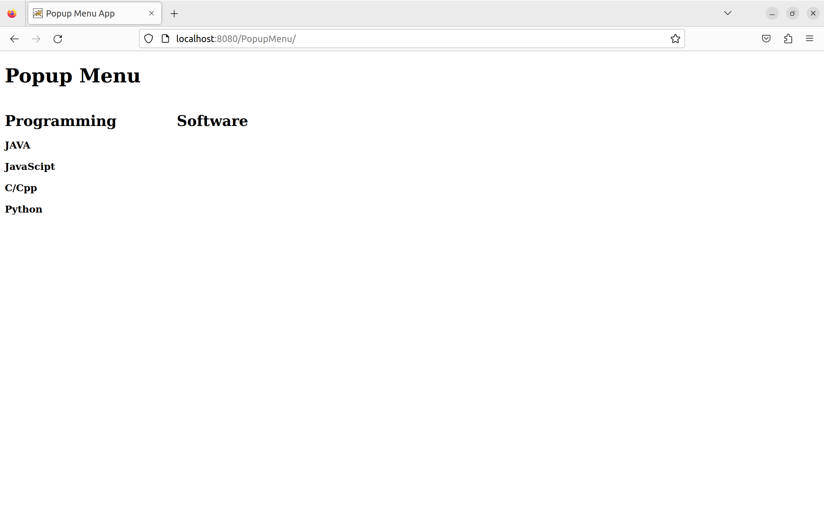
Move the mouse over “Software” or click on it to display Software content.

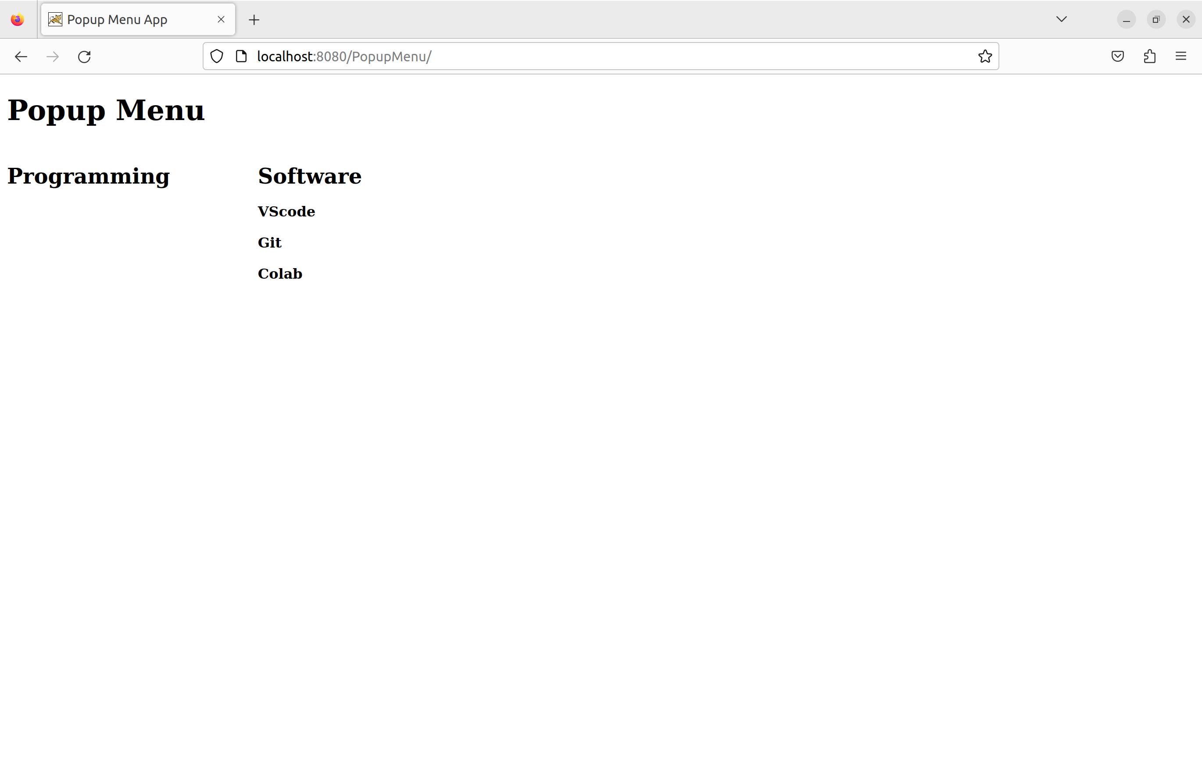

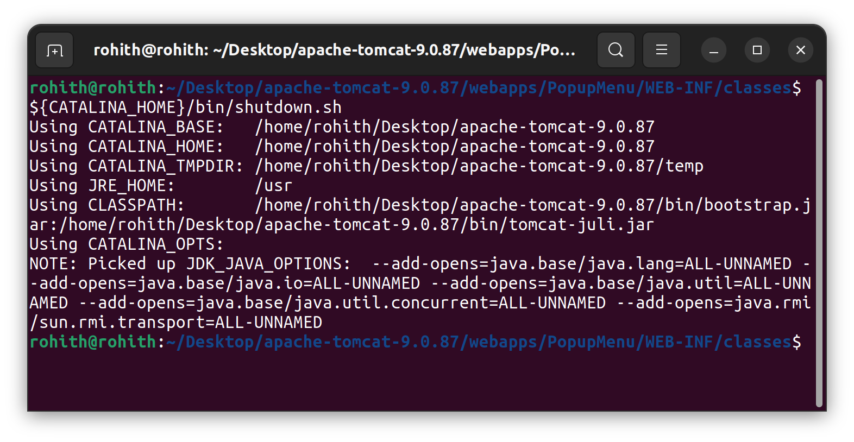

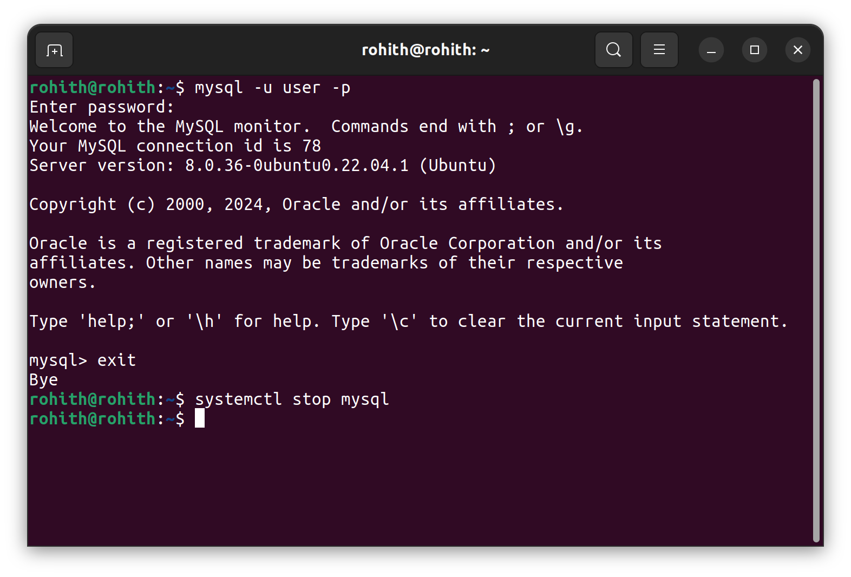
Best Practices to be followed:
1. Design before coding
2. Incremental coding
3. Usage of proper naming convention
4. Usage of Comments to the code
5. Indentation of code

